Collinear Points
# Source: AI Source: Provided by: [Data Path: Persons Table -> ID Column: 1, Name_En Column: Motasem Essam] -> From: [ChatGPT] on [7/25/2026]
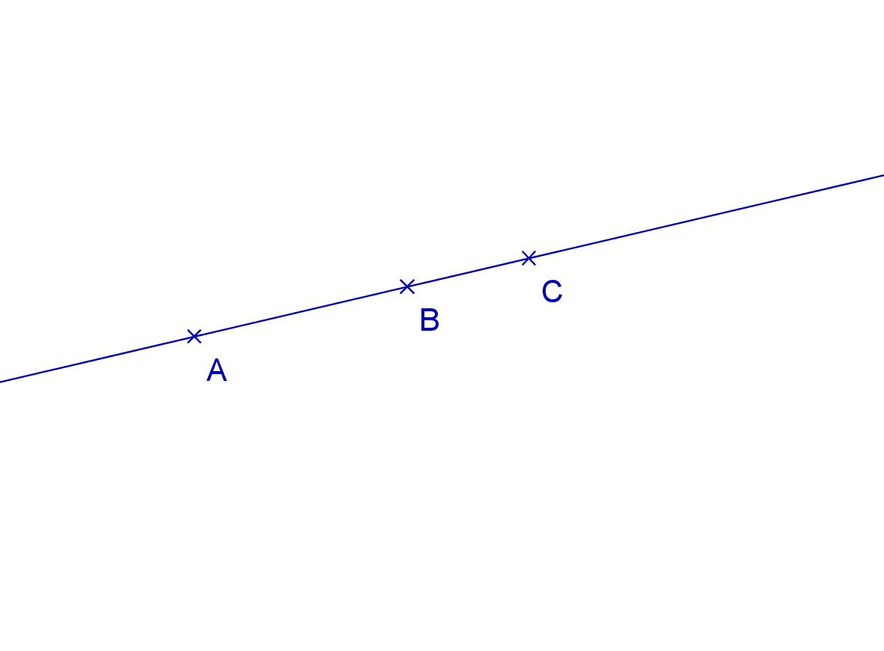
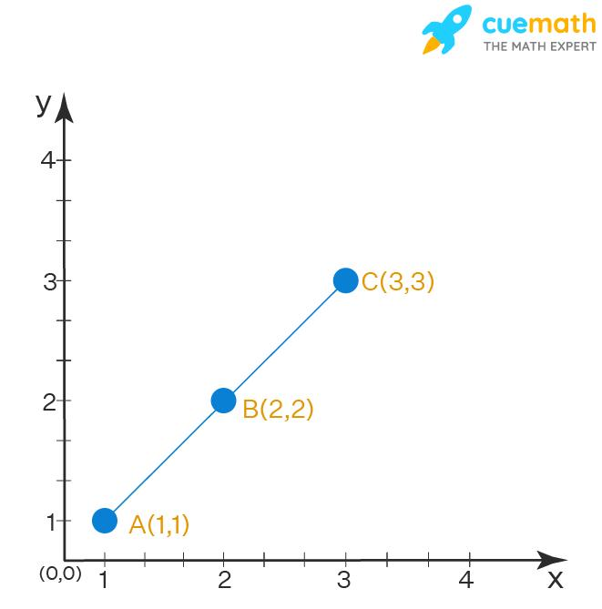

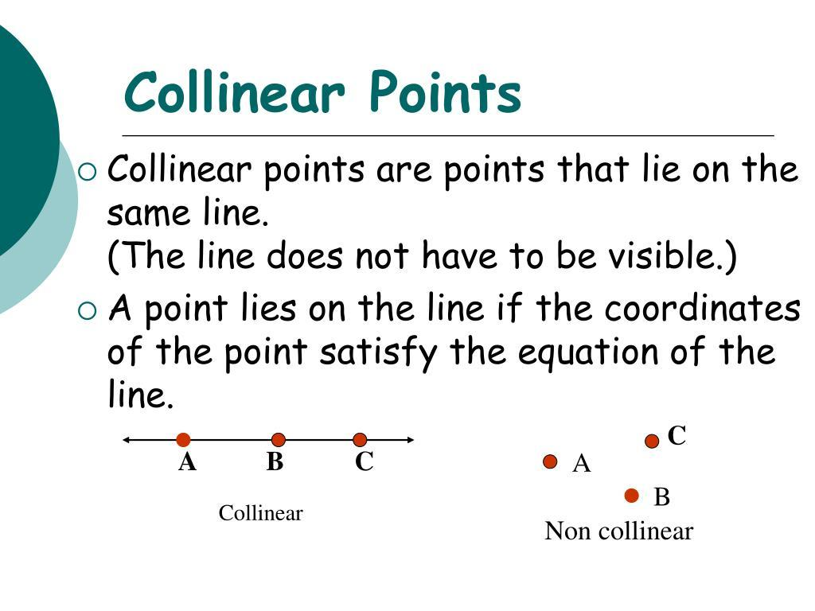
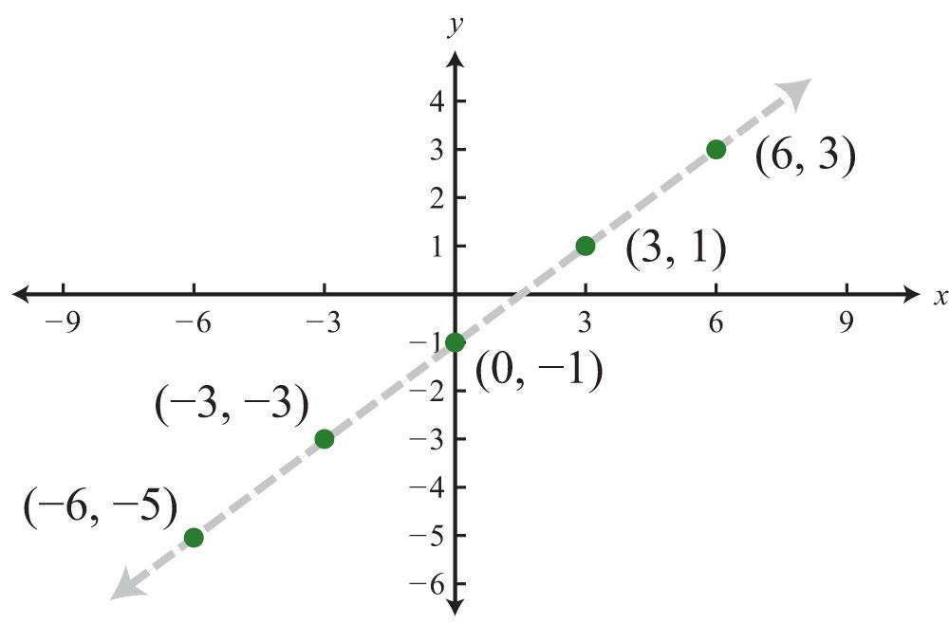
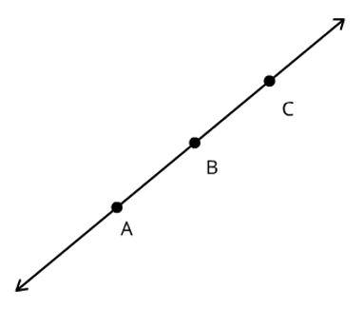
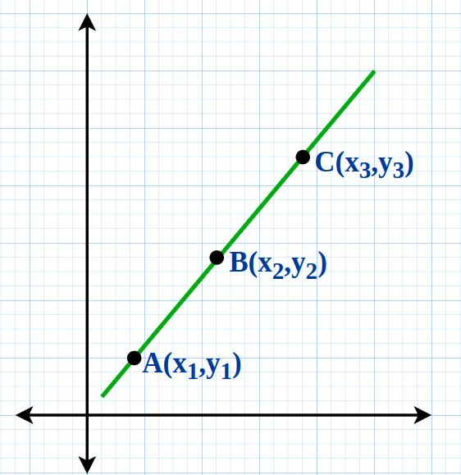

Definition
# Source: AI Source: Provided by: [Data Path: Persons Table -> ID Column: 1, Name_En Column: Motasem Essam] -> From: [ChatGPT] on [7/25/2026]
Collinear Points are two or more points that lie on the same straight line. If a single straight line can pass through all the points, they are said to be collinear.
Collinearity is one of the most fundamental concepts in geometry and is used to describe the alignment of points.

Characteristics
# Source: AI Source: Provided by: [Data Path: Persons Table -> ID Column: 1, Name_En Column: Motasem Essam] -> From: [ChatGPT] on [7/25/2026]
Collinear points:
- Lie on one straight line.
- Share the same linear alignment.
- May be separated by different distances.
- Can be finite or infinitely many on the same line.
- Are independent of the line's orientation (horizontal, vertical, or diagonal).

Illustration
# Source: AI Source: Provided by: [Data Path: Persons Table -> ID Column: 1, Name_En Column: Motasem Essam] -> From: [ChatGPT] on [7/25/2026]
A •────────• B────────• C
Points A, B, and C lie on the same straight line, so they are collinear.

Examples
# Source: AI Source: Provided by: [Data Path: Persons Table -> ID Column: 1, Name_En Column: Motasem Essam] -> From: [ChatGPT] on [7/25/2026]
Horizontal Collinear Points
A •────• B────• C

Vertical Collinear Points

A •
│
B •
│
C •

Diagonal Collinear Points
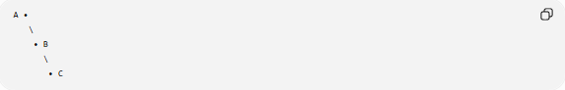
A •
\
• B
\
• C

Mathematical Representation
# Source: AI Source: Provided by: [Data Path: Persons Table -> ID Column: 1, Name_En Column: Motasem Essam] -> From: [ChatGPT] on [7/25/2026]
Points $A$, $B$, and $C$are collinear if they all lie on the same line:
$$A, B, C∈\overset{↔}{AB}$$

Coordinate Geometry
# Source: AI Source: Provided by: [Data Path: Persons Table -> ID Column: 1, Name_En Column: Motasem Essam] -> From: [ChatGPT] on [7/25/2026]
For three points:
$$A\left(x_{1} , y_{1}\right), B\left(x_{2} , y_{2}\right), C\left(x_{3} , y_{3}\right)$$
they are collinear if the slopes are equal:
$$\frac{y_{2}-y_{1}}{x_{2}-x_{1}}=\frac{y_{3}-y_{2}}{x_{3}-x_{2}}$$
provided the denominators are not zero.
Alternatively, they are collinear if the area of the triangle formed by the three points is zero.

Properties
# Source: AI Source: Provided by: [Data Path: Persons Table -> ID Column: 1, Name_En Column: Motasem Essam] -> From: [ChatGPT] on [7/25/2026]
Collinear points:
- Belong to the same straight line.
- May form line segments between consecutive points.
- Can be endpoints of rays or line segments.
- Do not form a triangle when only three distinct collinear points are considered.

Applications
# Source: AI Source: Provided by: [Data Path: Persons Table -> ID Column: 1, Name_En Column: Motasem Essam] -> From: [ChatGPT] on [7/25/2026]
Collinear points are used in:
- Geometry
- Coordinate Geometry
- Surveying
- Engineering
- Architecture
- CAD (Computer-Aided Design)
- Computer Graphics
- GIS (Geographic Information Systems)
- Robotics
- Navigation

Advantages
# Source: AI Source: Provided by: [Data Path: Persons Table -> ID Column: 1, Name_En Column: Motasem Essam] -> From: [ChatGPT] on [7/25/2026]
Studying collinear points helps to:
- Describe alignment.
- Analyze geometric relationships.
- Verify line equations.
- Support geometric proofs.
- Simplify engineering and surveying calculations.

Limitations
# Source: AI Source: Provided by: [Data Path: Persons Table -> ID Column: 1, Name_En Column: Motasem Essam] -> From: [ChatGPT] on [7/25/2026]
Collinear points:
- Cannot define a unique plane by themselves.
- Three collinear points cannot form a triangle.
- Depend on accurate point positioning.

Comparison with Non-Collinear Points
# Source: AI Source: Provided by: [Data Path: Persons Table -> ID Column: 1, Name_En Column: Motasem Essam] -> From: [ChatGPT] on [7/25/2026]

Type | Description
Collinear Points | Lie on the same straight line
Non-Collinear Points | Do not lie on the same straight line

Key Points
# Source: AI Source: Provided by: [Data Path: Persons Table -> ID Column: 1, Name_En Column: Motasem Essam] -> From: [ChatGPT] on [7/25/2026]
- Collinear Points lie on the same straight line.
- Any number of points may be collinear.
- Three collinear points cannot form a triangle.
- Collinearity is used extensively in geometry, surveying, CAD, engineering, and coordinate geometry.

Conclusion
# Source: AI Source: Provided by: [Data Path: Persons Table -> ID Column: 1, Name_En Column: Motasem Essam] -> From: [ChatGPT] on [7/25/2026]
Collinear Points are points that share the same straight-line path, making them one of the most fundamental concepts in geometry. Their alignment is essential for defining lines, constructing geometric figures, verifying coordinate relationships, and solving spatial problems. Collinear points are widely applied in geometry, engineering, surveying, architecture, CAD, GIS, robotics, navigation, and computer graphics, where accurate linear alignment is critical for measurement, design, and analysis.

